**Guided Capstone Project Report**

Big Mountain Resort is a great company located in Montana that offers access to different types of parks and trails (approximately 115). Unfortunately, today the company is facing some financial issues related to the installation of the new chair lift. According to the accounting department, the expense of maintaining the new chair lift will be around $1,500,000 that is not maximizing its returns. So, the company decided to put its focus on finding a productive solution through an advanced crew team of data scientists.

What are the main objectives here? According to the current situation, we could consider two main ways of resolving (exiting) the financial difficulty. One of them is decreasing the operational cost on some trails (runs) in case to compensate for the expense of the new chair lift. The second one is based on increasing the cost of the admission ticket based on market value.

But, which way works better? What are those actions the company should take to fix the problem? So, they are all good questions that we will try to answer in a fairway. Let us begin by saying a few important things before the conclusion.

First of all, we should state that to make the model work accordingly (as expected), managing data should be robust and accurate. Unfortunately, some valuable information (about customers and their preferences or company business models) was missing. Also, some data about other facilities was misrepresented (it required deletion or additional research that in some ways negatively affected the outcome). That is why it is important to mention that all available data (related to this problem) should be provided in its requested and timely manner form from this company.

Secondly, we found a few interesting points to consider. One of them was that there was no clear relationship between state and ticket (pic. 1). Based on the provided picture below you can observe the red points, that are representing the upper quartile of price, spread around the picture, and not showing any valuable pattern. So, from that point, we decided to treat each state on the same level (without notable preferences). Additionally, we were able to find a few correlations, things that could manipulate the cost of the ticket (pic 2).

And finally, we trained (tested) a few models using our data. But, only one worked as we desired. The name of the model we used was "The Random Forest". It had lower cross-validation mean absolute error. In other words, it predicted better than others with lower room for price error (pic 3).

In conclusion, if we are taking into consideration that the current charge for an admission ticket is $81, and there is still room to increase the price by $5-$10 (within mean absolute error). This assumption is purely based on the idea that other resorts accurately set their prices based on market support accordingly. Also, we could add here that if the company will consider adding one more chair lift then annual revenue will be on the same level or most likely less, because of the additional expense of that service. But, if the company will consider investing in a feature like "vertical drop" then there will be an opportunity to increase by almost $2 the ticket cost. Important to mention, that company also could preserve some money via decreasing the operating cost on some runs (around 3 of them) that will not affect the cost of admission.

***Picture 1***

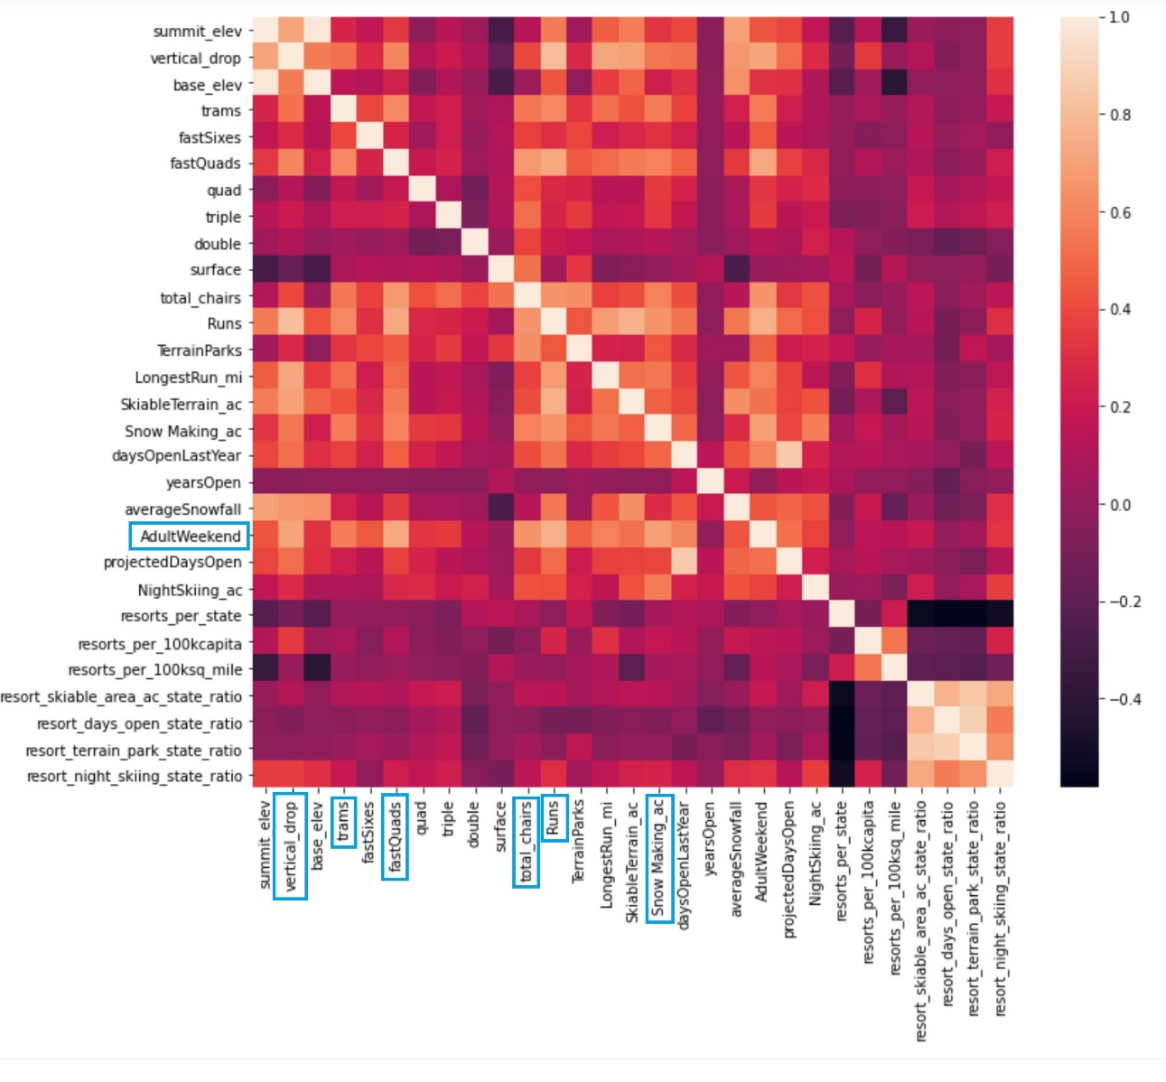

***Picture 2***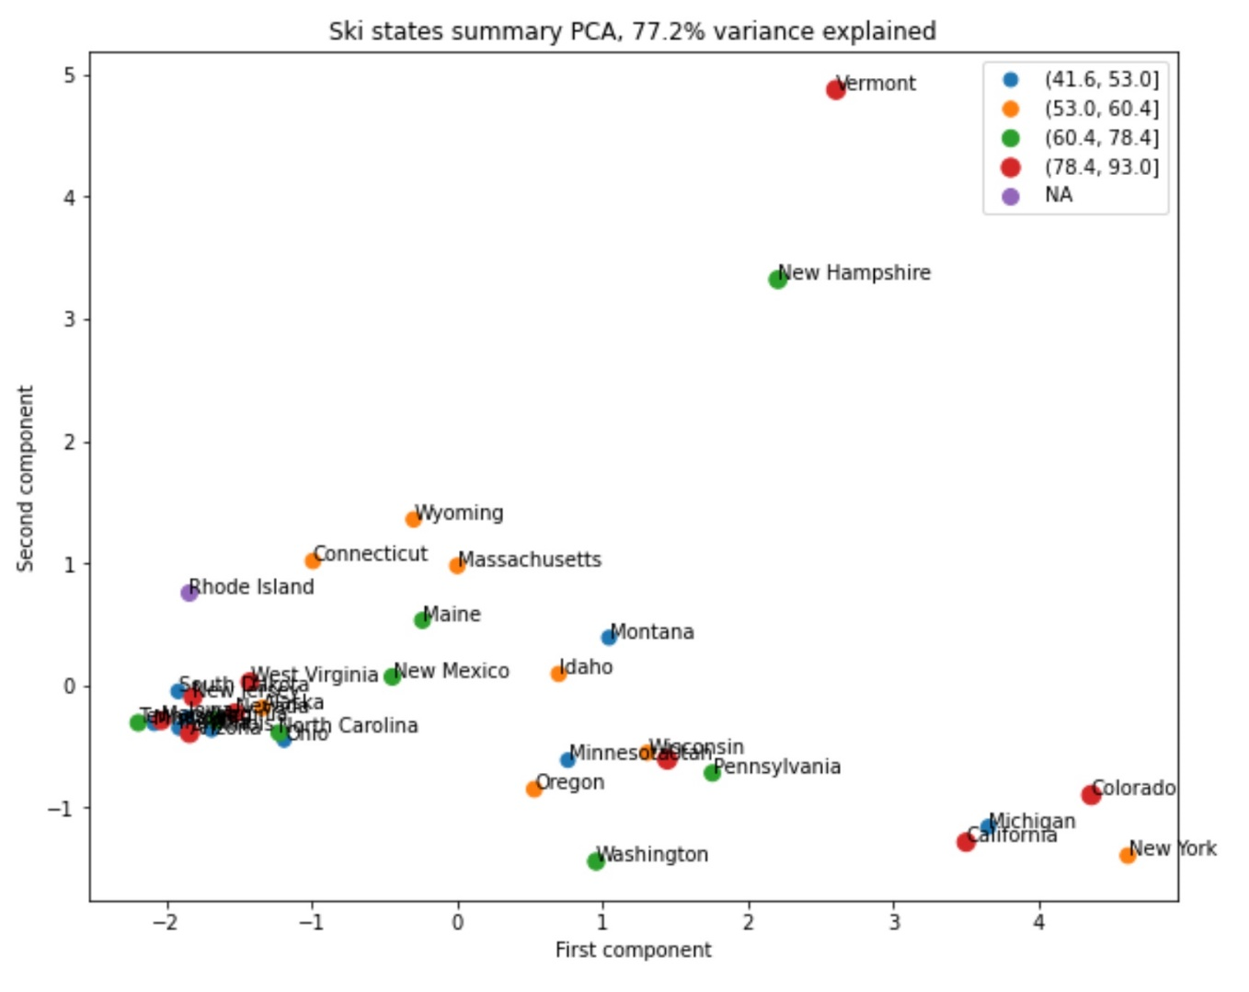

***Picture 3***

